EXAMPLES OF LOTO DEVICES

http://www.reecesafety.co.uk/Padlocks.htm
http://www.masterlock.com/

Lockout Hasps
Safety lockout hasps allow multiple padlocks to be used when isolating one energy source. The lockout hasp is placed through the isolating point and each person carrying out maintenance or service work attaches and locks in place their own unique individually keyed padlock through the lockout hasp. This ensures each worker's safety as the energy cannot be restored until the work is finished and all padlocks have been removed.

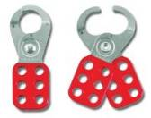
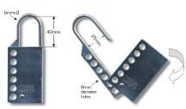
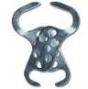

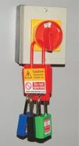
Nonconductive Lockout Hasp
Manufactured from strong rigid red plastic this lockout hasp has excellent
electrical insulating characteristics and is highly resistant to cracking and most chemicals.

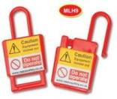

Padlocks
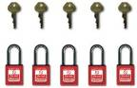

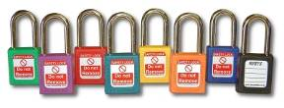

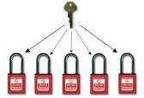

Safety Lockout Tags

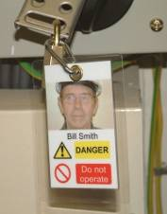
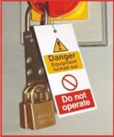
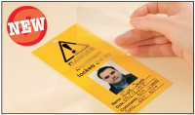

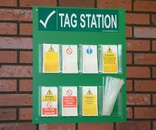

Tag Stations

Valves isolation

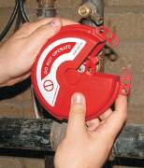
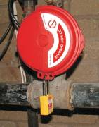
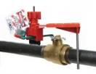
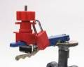

Cable Lockouts

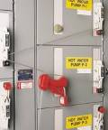
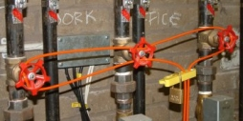
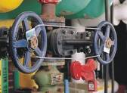

Lockout Boxes
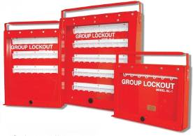
Safety lockout boxes are ideal for group lockout situations. After the equipment to be worked on has been locked off, all lockout keys/fuses etc are placed inside the lockout box and locked by the responsible person using the control key. Each worker then removes and retains a secondary key ensuring access cannot be gained to the keys/fuses etc inside until all work is completed and all secondary keys returned. Only when all secondary keys are in position, can the responsible person open the lockout box using the control key.

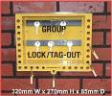
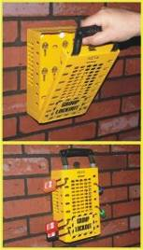

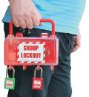
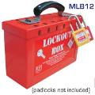

Crane Pendant Lockout
Our versatile pendant lockout bag is manufactured from durable anti-rip nylon. Simply place the hoist control in the nylon bag which blocks access to the buttons. Complete with a durable flexible pull-tight draw clamp which will accept up to 6 padlocks to secure.
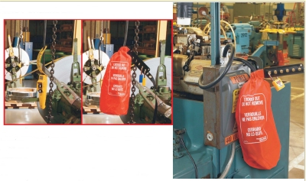

Industrial Plug Lockout & Bag

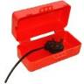
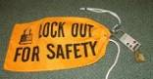
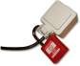
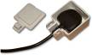
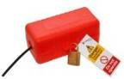

Pneumatic Lockout
Isolate pneumatic energy without the expense of installing in-line lockout valves. Our pneumatic lockout is applied to the male fitting, isolating equipment from all compressed air sources.
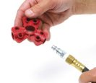
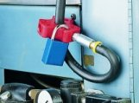

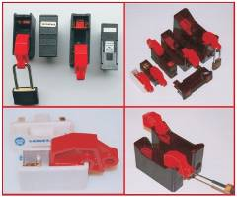
Universal Lockout Device for Fuse Holders

Circuit Breaker Lockouts
Our range of circuit breaker lockouts are now available for either single or double pole circuit breakers. Manufactured from rigid plastic this range of circuit breaker lockouts allow breakers to be locked off individually.

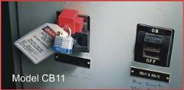
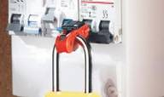

Breaker Blocker 480-600V lockout
• Perfect for locking out oversized and irregularly shaped switches
• Self-adhesive backed rails are permanently installed into an electrical panel – simply clean panel surface and adhere – no drilling required!
• Blocking bars (red and green) are 190 mm long
• Red blocking bar indicates locked off, green bar indicates locked on
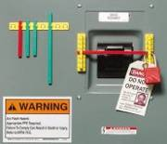
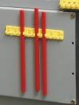
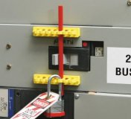

Lockout Equipment Box and station

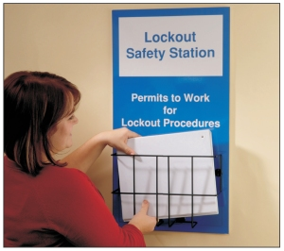
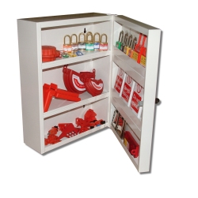
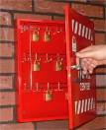

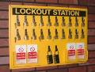

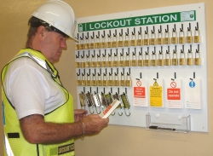

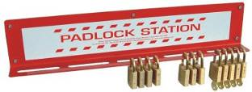

Keys cabinet
